**Sample paper(2023 – 2024)**

**Class :- II Subject :- Social Studies Time – 3hrs**

**Date :- __________________ Name-___________________________ MM :- 80**

**Instructions :-1. Attempt All the Questions**

**2. Answer all the questions Sequentially.**

**Multiple Choice Question Section – A Total -- 30**

**Q1. Tick (√) the correct answer (10 Marks)**

1. **______________ is house on water.**

caravan (b) tent (c) Igloo (d) house boat

1. **We deposit money here ___________.**
2. Police Station (b) Post office (c) Railway Station (d) bank
3. **The Hindus visit the _____________________ to pray.**
4. Mosque (b) Temple (c) Church (d) Gurudwara
5. **Hymns sung by Sikhs are called _____________________.**
6. Bhajans (b) Kirtans (c) Songs (d) All of the above

**We should eat __________________ diet.**

(a) unhealthy (b) Soil (c) Wheel (d) balanced

1. **________________pumps blood to all different parts of the body.**

Brain (b) Heart (c) lungs (d) Kidney

1. We must drink _____________ water.

(a) clean (b) Coke (c) Burger (d) Pizza

1. It is fun to live in a  **__________________.**

(a) hospital (b) neighbourhood (c) bank park

1. **The ___________ is the place of worship for Christians.**

(a) temple (b) church (c) mosque (d) gurudwara

9. __________________ helps us to think .

(a) Lungs (b) bone (c) brain (d) heart

**10. Children go to play here ___________________ .**

(a) School (b) Park (c) Market (d) Hospital

**Q2. Fill in the blanks :- (5 Marks)**

**Wool, Bhagawat Gita, post office, Temple, igloo**

1. The holy book of Hindus.__________________.
2. This is the Hindu place of worship.
3. ____________ is a natural fiber.
4. We post letter here ____________________.
5. House made of ice are called- ___________________________.

**Q3. True / False:- (5 Marks)**

1. Caravan is a mobile house.. **______________________**

2. We get wool from sheep . **______________________**

3. Lungs helps in breathing. . **______________________**

4. Cotton is a man made fibre. . **______________________**

5.Leather is made from animal skin.. **______________________**

**Q4. Match the following (5 Marks)**

**A B**

1. Hear music 1. tongue

2. Taste a cake 2. fingers

3. Smell a flower 3. foot

4. Run a race 4. ear

5. Hold a pencil 5. nose

**Q5. Identify the given picture— ( 5 Marks)**

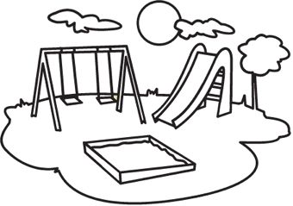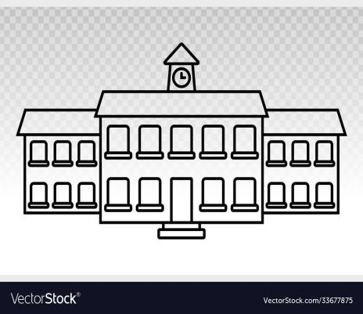

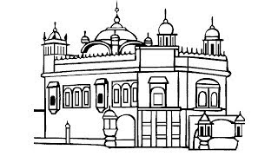



**Section – B Total --25**

**Q6. Answer in one word (any 4) (4 Marks)**

1. Deposit money **___________________________________________**
2. Manage law and order - **________________________________________**
3. Holy books of Christians - **________________________________________**
4. House on boat - **___________________________________________**
5. Holy books of Sikh - **___________________________________________**

**Q7. Answer in short (any 3) (6 Marks)**

1. What is inuits?
2. Why do we need a house?.
3. Write any three uses of water?
4. How many glasses of water should we drink every day?

Or

What are two different types of houses?

**Q8. Answer the following- (any 2) (6 Marks)**

1. What is the work of a brain?.
2. What are Energy–giving food?
3. Why are lungs important?
4. What is man made fiber?

Ans--

Ans-

**Q9. Define the following term (any 1) (2 Marks)**

1. Energy giving food. 2. Balanced diet

**Q10. Fill in the missing letter (2 Marks)**

1. SC__ ___OL . 2. TEM___LE
2. NY__ON . 4. BA____ K

**Q11. Name the following- (3 Marks)**

1. Any three protective food?

_______________________________________________________________________________________________________________________________________________________________________________________________________________________________________________________________________________________________________________________________________________________________________________________________________________________________________________________________________________________________________________________________________________________________________________________________-

_______________________________________________________________________________________________________________________________________________________________________________________________________________________________________________________________________________________________________________________________________________________________________________________________________________________________________________________________________________________________________________________________________________________________________________________________-

_______________________________________________________________________________________________________________________________________________________________________________________________________________________________________________________________________________________________________________________________________________________________________________________________________________________________________________________________________________________________________________________________________________________________________________________________-

**Q12. Write any two places of worship. (2 Marks)**

|  |  |
| --- | --- |
|  |  |
|  |  |
|  |  |
|  |  |

**Section – C Total --15**

**Q13. Explain the following - (4 Marks)**

**What are the different types of food? Give example.**

**Q14. Give reason - (6 Marks)**

Why it is important to drink only clean water?

1. What are the main sources of water? Draw any two.

**Q15. Write two different type of clothes with example . (2 Marks)**

____________________________________________________________________________________________________________________________________________________________________________________________________________________________________________________________________________________________________________________________________________________________________________________________________________________________________________________________________________________________________________________________________________________________________________________

**Q16. Why do we need a house? (3 Marks)**

**Section- D Total -- 10**

**Q17.Observe the pictures carefully and label and answer the following questions .**

**(5 Marks)**

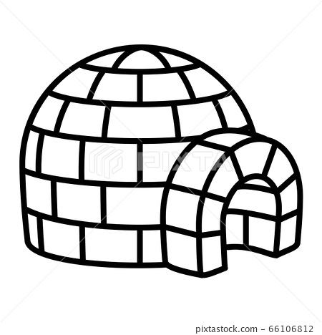

**Q1. What type of house is this?**

**Q18. The people who live in this house are called? And colour the picture.**

_______________________________________________________________________________________________________________________________________________________________________________________________________________________________________________________________________________________________________________________________________________________________________________________________________________________________________________________________________________________________________________________________________________________________________________________________-

_______________________________________________________________________________________________________________________________________________________________________________________________________________________________________________________________________________________________________________________________________________________________________________________________________________________________________________________________________________________________________________________________________________________________________________________________-